Tracing two members of the Royal Welsh Warehouse Football Team (1914)
Chris Roach, MGS Facebook Page Editor
This particular story, part of my family history journey started with a message in Ancestry from John Evans, Committee member of the Newtown Textile Museum, regarding an exhibition they are holding in the Summer/Autumn 2020. The exhibition will feature a photo of the Royal Welsh Warehouse (RWW) football team which won the Montgomeryshire Challenge Cup in April 1914. Many of the lads went on to join the army a few months later and John had identified some of their military records. My maternal great-uncle Percy Townsend was the goal keeper in the team but John had been unable to find any records for Percy and wondered if I could provide any information. My maternal Grand-father Bertram Evans was also in the team. Bert and Percy were to become brothers-in-law, when Bert married Percy’s sister, Tillie Townsend, in 1915.
Percy Townsend
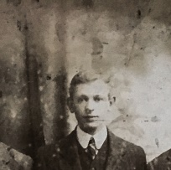
I contacted Gordon Townsend, Percy’s son who told me that his father had joined the Montgomeryshire Yeomanry which was amalgamated with the Royal Welsh Fusiliers and served in Gallipoli and the Western Front. He reached the rank of Sergeant, received medals and was mentioned in dispatches. My interest was by now fully engaged and I started my own investigations.
The Forces War Records site records a Sergeant Charles P Townsend of the Royal Welsh Fusiliers in the nominal index who received the British War Medal and the Victory Medal. Also, there is a C P Townsend who was a sergeant in the Royal Welsh Fusiliers, 24th battalion, who was mentioned in dispatches by Sir D Haig on 16th March 1919. On Ancestry I identified a Charles Percy Townsend on the WW1 Service Medal and Award rolls which confirmed that he was awarded the British War Medal and the Victory Medal. In all of these records the service number is 290954. However there was no address on any of these documents that conclusively proved that this was “our” Percy, until Percy’s grandson Rod Townsend unearthed solid evidence; a copy of the original certificate of the mention in dispatches, a Christmas card and a photograph of the battalion taken in 1915 whilst stationed at the Park Hall camp in Oswestry (see illustrations). This huge military camp was in constant use during the war, training and dispatching troops to the front line of battle. Thankfully Percy did survive the war and returned home to Newtown. He married in 1923 and moved to Llanidloes in 1939. He died in 1975 at the age of 83.
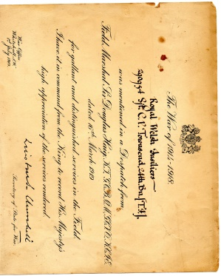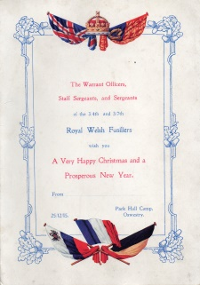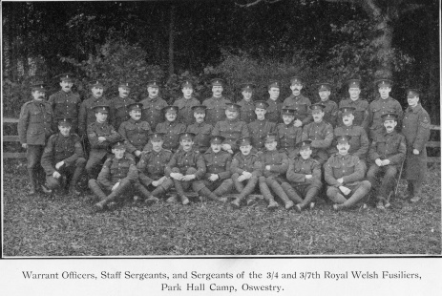
Bert Evans
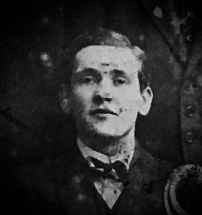
Although the Townsend’s were a sporting family and my Mum and Uncles had followed this tradition I never realised that my Grand-father, Bert Evans, was also a sportsman. The extent of my knowledge was that he had fought in WW1 and had been injured. Unfortunately it appears that his war records were not amongst those that survived or at least none that I have been able to find. All I have to go on is his obituary in the County Times which states that he was stationed in Ireland and saw active service in France where he was badly gassed.
So my search continues, and I may never have the answers, unless of course someone out there knows something…….
My contact details are on the inner page of this journal and I monitor the MGS Facebook page.
The Newtown Textile Museum is still hoping to be able to go ahead with their exhibition this year, depending on the situation regarding the Corona virus. If anyone is interested in going along, up to date information can be found on their website; http://www.newtowntextilemuseum.co.uk/

